Marella Morad

Sprint 1 Stage
Estimation Reflection 1 – 62C

Table of Contents
Introduction 2
Evidence 2
JIRA Borad Tasks 2
GitHub Commit History 2
Accuracy Analysis 3
Reasons for Accuracy 3
Experience 3
Detailed Task Breakdown 3
Justification 3
Improvement Strategies 3

Introduction
In this reflection report, I will assess the accuracy of my initial effort estimation for the development of the "Member Management Web Pages" during Sprint 1. The original estimation was 480 minutes (8 hours), and the actual time spent on the tasks was 9 hours. I will discuss the reasons for the variance and provide insights into improving future estimations.

Evidence

JIRA Borad Tasks
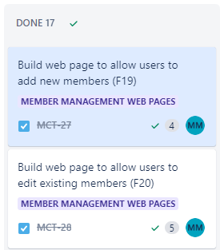

GitHub Commit History
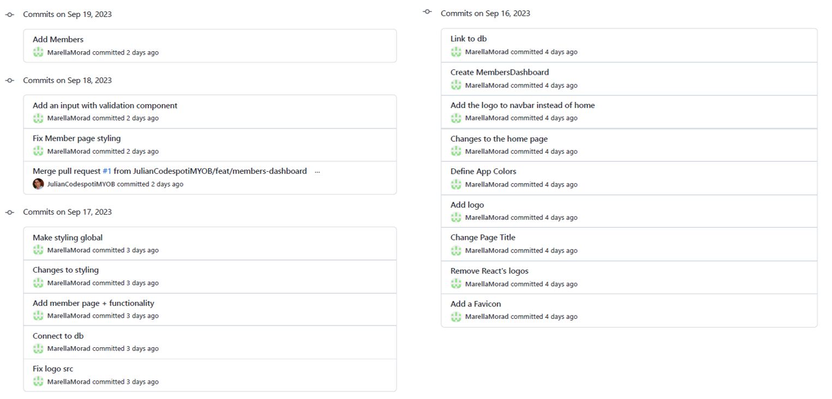

Accuracy Analysis
The original estimation for this project was reasonably close to the actual effort, with only a 12.5% variance. While this falls slightly outside the 10% range, it is still a relatively accurate estimation considering the complexity of the tasks involved.

Reasons for Accuracy
Experience
My previous experience with web development, both academically and professionally, played a crucial role in making accurate estimations. Having a solid understanding of the development process, including design, development, integration, testing, and deployment, allowed me to gauge the effort required for each task accurately.
Detailed Task Breakdown
Breaking down the project into smaller tasks, each with its own estimation, helped in identifying potential bottlenecks and areas that might require more time.

Justification
Providing detailed justifications for each task's estimation allowed for a clear understanding of why a particular amount of time was allocated to it. This transparency helped in assessing the estimations more critically.

Improvement Strategies
Although my estimations were reasonably accurate in this sprint, continuous improvement is vital. To enhance my estimation accuracy, I’ll implement two key strategies. Firstly, I’ll conduct regular retrospectives at the end of each sprint to scrutinize estimation accuracy, pinpoint discrepancies, and dissect the underlying reasons. These insights will serve as a foundation for refining future estimations. Secondly, recognizing the significance of contingency planning became evident during this task, particularly when developing the Edit/Delete Members web page. I encountered unforeseen delays while attempting to establish a connection to the members' table to retrieve, view, edit, or delete records. These unexpected issues consumed an additional hour as I worked diligently to identify the root cause. Fortunately, with the assistance of a team member, we were able to resolve the issue promptly, enabling me to get back on schedule. This firsthand experience underscores the importance of allocating buffers within estimations to accommodate such unforeseen challenges, reinforcing the need for a more robust and adaptable project management approach in future sprints.

